

Netlight Streaming Guide

2017-01-13

At Netlight we thrive on being on the edge of innovation – new is good! Streaming is a way for all of Netlight to take part in real-time in the breadth of amazing events occurring in all of our offices.

# Contents

1 Contents 1

2 Introduction 2

3 Setup 2

3.1 Prerequisites 2

3.2 Wirecast 3

3.3 Youtube 3

4 Devices 4

4.1 Beginner Streaming Setup 4

4.2 Advanced Streaming Setup 4

4.3 Professional Streaming Setup 4

5 Streaming 5

5.1 Prerequisites 5

5.2 Start a stream 5

5.3 Operating the stream 6

6 FAQ 7

# Introduction

Whether you are an IT professional or an event organizer at your office: this document is for you. It explains what you will need for streaming and how to setup software and hardware. There’s also a section on recommended hardware and finally some FAQ.

Over the course of this guide you may have to aquire a license and install software on a dedicated streaming computer. Overall setup until you are ready to start your first stream will be between 30 and 120 minutes depending on the complexity that you choose. In addition you may have to purchase devices that are not available at your office.

Lastly, this document is a **work in progress**! In case of Feedback and / or additional questions you can always get in touch with people that have been involved with streaming at your office

* [Ferdinand von den Eichen](mailto:ferdinand.vondeneichen@netlight.com) (General Questions & Accounts)
* [Denis Hamann](mailto:denis.hamann@netlight.com) (Hamburg)
* [Adam Bakai](mailto:adam.bakai@netlight.com) (Munich)
* [Niclas Edenvin](mailto:niclas.edenvin@netlight.com) (Stockholm)

Alternatively, feel free to reach out in #netlight-streaming!

# Setup

Our suggested streaming system consists of software to aggregate, process and upload all the inputs – in this case Wirecast – and the platform to consume the stream in, for which we have chosen Youtube. To minimize continuous effort we suggest to use a dedicated machine.

## Prerequisites

* A preferably dedicated computer with either Windows 7 SP1 64-bit, Windows 8.1 64-bit, Windows 10 64-bit or Mac OS X El Capitan, macOS Sierra. Please note: Wirecast 7 does not support OS X Yosemite or previous versions of OS X.
* Internet connectivity
  + For lowest quality (240p) streaming an upload rate of at least 650Kbps is required
  + 720p streaming requires an upload rate of at least 2500 Kbps
  + 1080p streaming requires an upload rate of at least 4500 Kbps
* Hardware requirements
  + Intel Core i3 CPU @ 1.7 Ghz or higher recommended for 540p streaming with x264 @ 30 fps.
  + Intel Core i5 CPU @ 2.5 Ghz or higher recommended for 720p streaming with x264 @ 30 fps.
  + Intel Core i7 CPU @ 3.0Ghz or higher recommended for 1080p streaming with x264 @ 30fps.
  + Note: 60 FPS streaming will result in increased CPU usage and a high bit rate (4Mbps or higher) for good quality.
  + Intel HD, NVIDIA GeForce, or AMD Radeon class graphics adapter that are both DirectX 9 and DirectX 10 capable.
  + Minimum 4GB RAM, 2GB free hard disk space. Additional hard disk space required for recording to disk.

## Wirecast

As mentioned wirecast is software to preprocess and upload any number of feeds. You can freely combine camera input, microphones, remote and local screens and many more. We also went with Wirecast, because of its single purchase licensing model. The following steps will guide you through the setup.

1. Download and install Wirecast 7 or higher at <http://www.telestream.net/controls/wirecast/download-wirecast.htm>
   1. During installation you can start out with the free trial and upgrade later.
   2. We recommended **Wirecast Studio 7**, as it has all the features we need. There will have to be **one license per Netlight office** so check with any of the contact persons above for existing licenses. If you just bought a license, why not let us know? ☺
2. Download one of our prepared Wirecast templates (.wcst) and one intro and outro video from [the rebel page](https://rebel.netlight.com/edge/streaming/).
   1. The type of template roughly describes the complexity. For your first stream it may be better to start out with a simpler one, that only has a few inputs.
   2. Should you open it now, the template will ask you to fill the inputs with devices and source connected to your computer, which you may not have prepared at this point – that’s fine.
3. Add add a new output to Wirecast
   1. Choose Youtube as the destination
   2. Pick Encoding that suits your upload and hardware. Suggested values at the beginning of this chapter.
   3. Log into your Office or the global Netlight account (see introduction for contact people for account info)
   4. Make sure the event you are using is **set to private / unlisted**

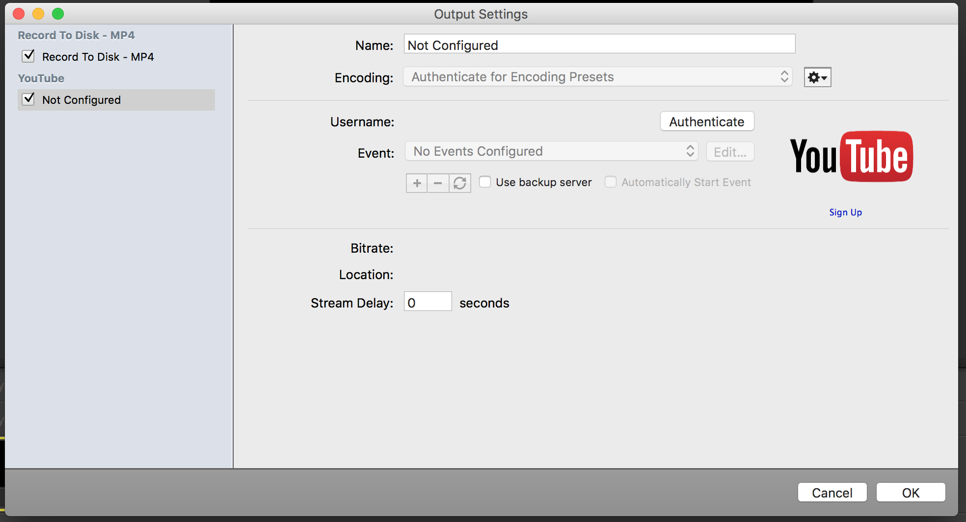

Abbildung 1 - Add a new output

## Youtube

Log into your preferred Youtube account. For Netlight wide events this should be the global Netlight account, otherwise your office account may be the better choice. For account details see the introduction.

1. Open the Creators Studio
2. Under Live Streaming > Events create a new event.
   1. You can either use one event all the time or create new ones for every actual event that you stream
3. Adjust privacy
   1. Set the events visibility to unlisted (means everyone with the link can watch the stream, but it can't be found by searching)
   2. Under Advanced Settings > Recording check the option to automatically make the archive unlisted once the even is over

# Devices

Generally speaking Wirecast will work with any input you throw at it. So you are free to combine multiple cameras and microphones to your liking. With that being said, here is what we consider the base solution and a somewhat more advanced setup. They largely follow the templates from [the rebel page](https://rebel.netlight.com/edge/streaming/).

## Beginner Streaming Setup

|  |  |  |
| --- | --- | --- |
| Device | Price | Description |
| Highend Smartphone | 0€ | Use the smartphone both for video feed and audio. Optionally a Bluetooth audio recorder may be attached to the smartphone to improve audio quality |

## Advanced Streaming Setup

|  |  |  |
| --- | --- | --- |
| Device | Price | Description |
| Logitech HD Pro Webcam C920 | 100€ | Solid mid range camera with 1080p support. Requires Windows 7, 8, 10 or Maxc Os 10.6+. On mac installation of drivers is required. |
| Jabra SPEAK 510 USB/Bluetooth Portable Audio Conferencing | 80€ | Good Speech quality and speaker is free to move. Uses usb or bluetooth. Battery is fine, after 3.5h it still had 70% battery. May not work well in very noisy or large halls. |

## Professional Streaming Setup

|  |  |  |
| --- | --- | --- |
| Device | Price | Description |
| Panasonic HC-V777EG-K | 450€ | High Quality Full HD Camcorder |
| Sony FDR-AX53 | 850€ | High End Camcorder |
| Movo WMIC50 | 115€ | Wireless Lavalier Microphone |
| UltraStudio Mini Recorder | 180€ | Captures Video (and Audio) from a HDMI Source. HDMI Source can be a Video Camera with HDMI Output or a Computer. The specified Adapter uses Thunderbolt. As a result it works with TB Notebooks (Macbooks & some other Notebooks). Installation was easy, setup is plug n play after installing the provided Drivers |

# Streaming

## Prerequisites

* You’ve created an event in your Youtube account
* You’ve installed Wirecast on the computer of your choice
* You’ve downloaded the Wirecast Template and the intro and outro video of your choice (from [the rebel page](https://rebel.netlight.com/edge/streaming/))

## Start a stream

Ensure your notebook is connected to a power source. Streaming has quite a strain on your computer, so be sure to hook your notebook to a power plug, this let’s the computer run at full speed.

Before starting Wirecast you should plug in all inputs that you plan on using. As you open the template, you will be asked to fill in all the missing inputs, including the intro and outro video that you downloaded earlier. The following section includes some troubleshooting on adding some of these input categories.

|  |  |
| --- | --- |
| Input Type | Setup |
| Cameras | Should be shown as an external device. |
| iPhone | Download Wirecast Cam. Make sure to be on the same Wifi as the computer with Wirecast. |
| Audio | Should be shown as an external device, depending on type it may be system audio. You may have to connect a wireless microphone by bluetooth. Be sure to pair the device first before usage (Windows & Mac OS X) |
| Presenter Machine | Recommended to connect to via [Desktop Presenter](http://dynamic.telestream.net/downloads/download-desktop-presenter.asp?prodid=desktoppresenter), which is dead easy to setup on the presenting machine. |
| Video | Just choose the video you downloaded earlier from [the rebel page](https://rebel.netlight.com/edge/streaming/). |

Congrats, you have finished the setup and are ready to go! ☺

## Operating the stream

Time to push the button! Pushing this button will immediately start broadcasting to Youtube.

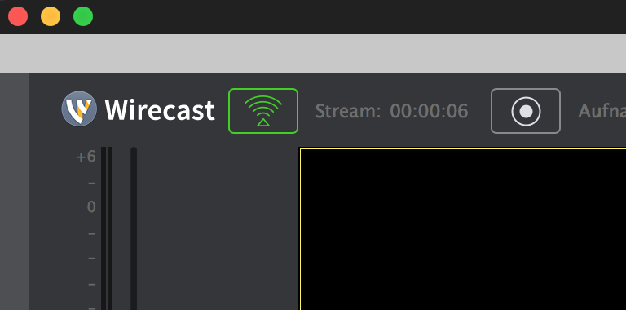

It is recommended to start the stream early and leave it in introduction mode until the actual event starts. Not only will this give confidence to your viewers, it will also give you time to check that everything is working as expected. Whenever you are ready, or want to make a change to the live scene, you need to first adjust the preview and then push your change to the live feed.

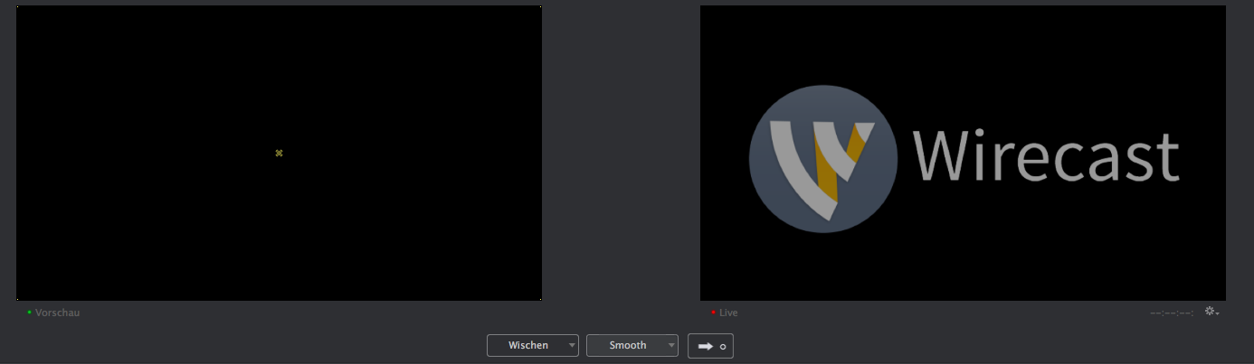

During the stream you may want to switch between different scenes, to show the audience or the presenter. This can be done in the lower section of the interface. Just choose the plane that you want to use and disable the others. Remember you can safely play around here and push the change to live when you are happy with the result!

# FAQ

Coming soon.